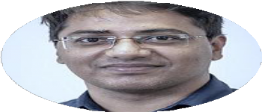Madan Mohan Rayguru

Experienced researcher and educator in robotics, control systems and AI, specializing in reconﬁgurable robots, human-robot collaboration, and energy systems.

* **Google Scholar Profile**: <https://scholar.google.co.in/citations?user=BA2izN0AAAAJ&hl=en>
* **ResearchGate Profile**: <https://www.researchgate.net/profile/Madan_Rayguru>
* **Web of Science**: https://[www.webofscience.com/wos/author/rid/W-6628-2019](http://www.webofscience.com/wos/author/rid/W-6628-2019)
* **ORCiD**: 0000-0003-4426-6364

**Research Interests:**

• Human-Robot Collaboration

• Robotics

• Safety Critical Learning with contraction theory

• Reconfigurable Systems

• Systems with switching and uncertainty.

**Experience:**

**Assistant Professor (Term) (August 2024- Current)**

Department of Information Systems, College of Business., UofL

**Assistant Professor (Term) (Jan 2024-July 2024)**

CSE Dept, J.B. Speed School of Eng., UofL

**Postdoctoral Fellow (June 2023-Dec 2023)**

LARRI, UofL

**Assistant Professor (June 2021-Dec 2022)**

Delhi Technological University, India

**Research Fellow (Mar 2020-Mar 2021)**

Reconfigurable Robotics Lab, Singapore University of Technology and Design, Singapore

**Assistant Professor (May 2019-Dec 2019)**

Electrical Engineering Department, VIT Vellore, India

**Education:**

**MS, Business Analytics**

University of Louisville, Kentucky, USA

(Jan 2023- Dec 2023), GPA-3.9

**Ph.D, Automation & Control**

Indian Institute of Technology Delhi, India

(Jan 2013 – Nov 2018), GPA- 3.9

**M. Tech, Automation & Control**

National Institute of Technology Rourkela, India

(2010 – 2012), GPA- 3.9

**B. Tech, Applied Electronics**

Biju Patnaik University of Technology, India

(2006 – 2010), GPA- 3.6

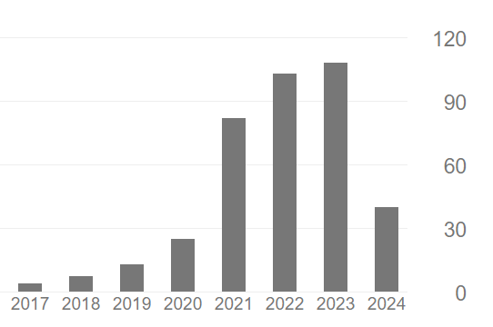

# **Publication Metrics**

* Citations 384
* h-index 10
* 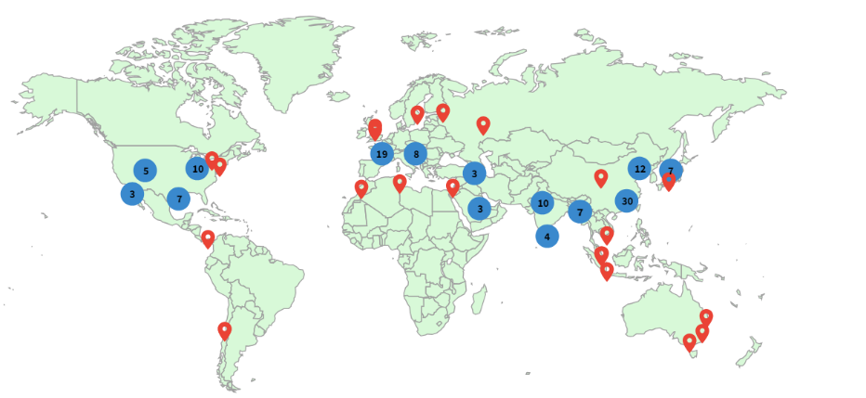i10-index 10

Geographic Citations

Citations over the years

# **Publications (In the Order of Citations Count)**

# Ramalingam, Balakrishnan, Jia Yin, Mohan Rajesh Elara, Yokhesh Krishnasamy Tamilselvam, **Madan Mohan Rayguru**, MA Viraj J. Muthugala, and Braulio Félix Gómez."A human support robot for the cleaning and maintenance of door handles using a deep-learning framework", *Sensors* 20, no.12 (2020): 3543

# **MM Rayguru**, RE Mohan, R Parween, L Yi, AV Le and S Roy, "An output feedback based robust saturated controller design for pavement sweeping self-reconfigurable robot", *IEEE/ASME Transactions on Mechatronics* 26, no.3 (2021): 1236-1247

# MRE Rizuwana Parween, Manuel Vega and **Madan Mohan Rayguru**, "Autonomous Self-reconfigurable Floor cleaning Robot", *IEEE Access* (2020)

# B Ramalingam, AA Hayat, MR Elara, B Félix Gómez, L Yi, T Pathmakumar, **M M Rayguru** ..., "Deep learning based pavement inspection using self-reconfigurable robot", *Sensors* 21, no.8 (2021): 2595

# MAVJ Muthugala, SMBP Samarakoon, **M Mohan Rayguru**, B Ramalingam and ..., "Wall-following behavior for a disinfection robot using type 1 and type 2 fuzzy logic systems", *Sensors* 20, no.16 (2020): 4445

# **M.M.Rayguru**, INK "Contraction-based stabilisation of nonlinear singularly perturbed systems and application to high gain feedback", *International Journal of Control* (2016)

# **MM Rayguru**, S Roy and IN Kar, "Time-scale redesign-based saturated controller synthesis for a class of MIMO nonlinear systems", *IEEE Transactions on Systems, Man, and Cybernetics: Systems* 51, no.8 (2019): 4681-4692

# **MM Rayguru** and IN Kar, "Contraction theory approach to disturbance observer based filtered backstepping design", *Journal of Dynamic Systems, Measurement, and Control* 141, no.8 (2019): 84501

# **MM Rayguru** and IN Kar, "High gain observer-based saturated controller for feedback linearizable system", *IEEE Transactions on Circuits and Systems II: Express Briefs* 67, no.1 (2019): 122-126

# **MMRayguru**, IN Kar, "Contraction Based Stabilization of Approximate FeedbackLinearizable Systems", *Europian Control Conference* 2015, (2015): 587-592

# T Pathmakumar, **MM Rayguru**, S Ghanta, M Kalimuthu and MR Elara, "An optimal footprint based coverage planning for hydro blasting robots", *Sensors* 21, no.4 (2021): 1194

# **M Mohan Rayguru**, M Rajesh Elara, B Ramalingam, MAV J. Muthugala and ..., "A path tracking strategy for car like robots with sensor unpredictability and measurement errors", *Sensors* 20, no.11 (2020): 3077

# JH Abhisek Nayak, **Madan Mohan Rayguru** and Sukumar Mishra, "A Quantitative Approach for Convergence Analysis of a Singularly Perturbed Inverter-Based Microgrid", *IEEE Transactions on Energy Conversion* (2021)

# **MM Rayguru**, S Roy, L Yi, MR Elara and S Baldi, "Introducing switched adaptive control for self-reconfigurable mobile cleaning robots", *IEEE Transactions on Automation Science and Engineering* 21, no.2 (2023): 2051-2062

# **MM Rayguru**, S Madichetty and S Mishra, "Battery super‐capacitor hybrid system for electrical vehicle transportation's systems–an energy integrated approach", *IET Energy Systems Integration* 2, no.3 (2020): 282-288

# **MM Rayguru**, MR Elara, R Parween, B Ramalingam, RE Abdulkader and L Yi, "A robust output feedback strategy for liquid handling using reconfigurable robots", *Automation in Construction* 130, (2021): 103800

# **M.M.Rayguru**, IN Kar, "A Singular Perturbation Approach to Saturated Controller Design with Application to Bounded Stabilization of Wing-Rock Phenomenon" (Nonlinear Dynamics, DOI: https://doi.org/10.1007/s11071-018-4323-x, 2018)

# B Subudhi, **MM Rayguru**, V Filaretov and A Zuev, "Design of a consensus based flocking control of multiple autonomous underwater vehicles using sliding mode approach", *Annals of DAAAM and Proceedings of the International DAAAM Symposium* (2017): 4-13

# Bhabani Shankar Dey, **Madan Mohan Rayguru**, IN Kar , "Output feedback for contraction of nonlinear singularly perturbed systems", *International Journal of Control* (2021)

# **MM Rayguru**, MR Elara, BF Gomez and B Ramalingam, "A time delay estimation based adaptive sliding mode strategy for hybrid impedance control", *IEEE Access* 8, (2020): 155352-155361

# **M Mohan Rayguru**, B Ramalingam and M Rajesh Elara, "A singular perturbation based adaptive strategy for bounded controller design in feedback linearizable systems", *International Journal of Adaptive Control and Signal Processing* 36, no.2 (2022): 264-281

# **MM Rayguru**, MR Elara, AA Hayat, B Ramalingam and S Roy, "Modeling and control of panthera self-reconfigurable pavement sweeping robot under actuator constraints", *2021 IEEE/RSJ International Conference on Intelligent Robots and Systems …* (2021)

# S Pookkuttath, MR Elara, **M Mohan Rayguru**, ZS Saldi, V Sivanantham and ..., "Snail: An Eco-Friendly Autonomous Steam Mopping Robot for Cleaning and Disinfection of Floors", *Mathematics* 11, no.5 (2023): 1086

# S Ghanta, **MM Rayguru**, T Pathmakumar, M Kalimuthu, MR Elara and ..., "Uniform hydro blasting for ship hull maintenance: A multi-objective optimization framework", *Ocean Engineering* 242, (2021): 109977

# A Ashary, **MM Rayguru**, P SharafianArdakani, I Kondaurova and DO Popa, "Multi-Joint Adaptive Motion Imitation in Robot-Assisted Physiotherapy with Dynamic Time Warping and Recurrent Neural Networks", *SoutheastCon* 2024, (2024): 1388-1394

# K Sehgal, S Upadhyaya, M Verma and **MM Rayguru**, "Backstepping based trajectory tracking control of a class of reconfigurable mobile robot", *2021 3rd International Conference on Advances in Computing, Communication …* (2021)

# S Kumari, **MM Rayguru** and S Upadhyaya, "Performance analysis of Linear Quadratic Regulator for DC-DC Converter Systems", *2023 International Conference on Power, Instrumentation, Energy and Control …* (2023)

# A Nayak, **MM Rayguru**, S Mishra and MJ Hossain, "A Quantitative Approach for Convergence Analysis of a Singularly Perturbed Inverter-Based Microgrid", *2023 IEEE Power &Energy Society Innovative Smart Grid Technologies …* (2023)

# L Yi, B Félix Gómez, B Ramalingam, **MM Rayguru**, MR Elara and AA Hayat, "Self-reconfigurable robot vision pipeline for safer adaptation to varying pavements width and surface conditions", *Scientific Reports* 12, no.1 (2022): 14557

# R Parween, MR Elara, ZS Saldi, T Ng and **MM Rayguru**, "Modeling and Analysis of a Glass Façade Robot", *Buildings* 11, no.6 (2021): 225

# **MM Rayguru** and IN Kar, "Convergence analysis of high gain disturbance observer based backstepping control: a contraction theory approach", *2017 Indian Control Conference (ICC)* (2017): 72-77

# A Ashary, **MM Rayguru**, J Dowdy, N Taghavi and DO Popa, "Adaptive Motion Imitation for Robot Assisted Physiotherapy Using Dynamic Time Warping and Recurrent Neural Network", *Proceedings of the 17th International Conference on PErvasive Technologies …* (2024)

# D Prasad, SK Valluru and **MM Rayguru**, "Filter based saturated controller design for a class of nonlinear singularly perturbed systems", *Sādhanā* 49, no.2 (2024): 184

# M Singh, **MM Rayguru** and G Kaushik, "Reinforcement Learning Based Controllers for Dynamical Systems", *2023 14th International Conference on Computing Communication and Networking …* (2023)

# D Rastogi, M Jain, **MM Rayguru** and SK Valluru, "Intelligent Control of Mobile Robots with ANN Assisted Improved Q-learning: IQ-CRL Algorithm", *2023 IEEE IAS Global Conference on Emerging Technologies (GlobConET)* (2023): 1-6

# S Kumari, **MM Rayguru** and S Upadhyaya, "Analysis of Model Predictive Controller versus Linear Quadratic Regulator for DC-DC Buck Converter Systems", *2023 7th International Conference on Intelligent Computing and Control …* (2023)

# MM Raza, **MM Rayguru** and G Kaushik, "Robust Model Predictive Control of a Buck Converter with Constraints", *2023 International Conference on Computational Intelligence and Sustainable …* (2023)

# D Rastogi, M Jain, **MM Rayguru** and SK Valluru, "Design &Validation of ANN based Reinforcement Learning Control Algorithm for Coupled Tank System", *2023 IEEE 8th International Conference for Convergence in Technology (I2CT)* (2023): 1-6

# A Maheshwari, A Rautela, **MM Rayguru** and SK Valluru, "Adaptive-Optimal Control for Reconfigurable Robots", *2023 International Conference on Device Intelligence, Computing and …* (2023)

# L Agarwal, B Jaint and **MM Rayguru**, "Byzantine Attack Detection in a WSN Using Extended Kalman Filter", *2022 IEEE International Conference on Service Operations and Logistics, and …* (2022)

# BF Gómez, L Yi, B Ramalingam, **MM Rayguru**, AA Hayat, P Thejus and ..., "Deep Learning based Litter Identification and Adaptive Cleaning using Self-reconfigurable Pavement Sweeping Robot", *2022 IEEE 18th International Conference on Automation Science and …* (2022)

# K Sehgal, M Verma, **MM Rayguru** and S Upadhyaya, "Effective Motion planning and Navigation for Reconfigurable Mobile Robots using Modified A* Algorithm", *2022 International Conference on Computational Intelligence and Sustainable …* (2022)

# R Parween, **MM Rayaguru**, S Yuyao, BCSC Sairam and MR Elara, "Design and development of a reconfigurable tiling robot", *Intelligent Service Robotics* 14, (2021): 629-639

# **MM Rayguru**, R Kumar, B Ramalingam and MR Elara, "Simultaneous Motion-Slosh Control for a Self-Reconfigurable Mobile Robot", *2021 International Symposium of Asian Control Association on Intelligent …* (2021)

# **MM Rayguru** and IN Kar, "Design of Contractive Output Feedback Controllers For Filtered Backstepping", *IFAC-PapersOnLine* 51, no.1 (2018): 30-35

**Editorial Responsibility**

Special Issue Frontiers Robotics & AI

**Veriﬁed Reviews**

8

6

4

Reviews

2

0

Aug 2019

Nov 2019

Feb 2020

May 2020

Aug 2020

Nov 2020

Feb 2021

May 2021

Aug 2021

Nov 2021

Feb 2022

May 2022

Aug 2022

Nov 2022

Feb 2023

May 2023

Aug 2023

Nov 2023

Feb 2024

May 2024

Month

**Reviews**

# Reviewer Summary

Manuscripts reviewed: 84 (As per web of science researcher and Scopus profiles)

(21) International Journal of Adaptiv… (18) IEEE Transactions on Circuits an…

(16) IEEE Transactions on Systems, … (11) IEEE Access

(7) IEEE/ASME Transactions on Mech… (4) IEEE Transactions on Circuits and…

(2) International Journal of Robust a… (1) IEEE Transactions on Industrial El…

(1) Advanced Intelligent Systems (1) IEEE Transactions on Automation…

(1) IEEE Transactions on Cognitive a… (1) Optimal Control Applications and…

ada